**DAILY ONLINE ACTIVITIES SUMMARY**

|  |  |  |  |  |  |  |  |
| --- | --- | --- | --- | --- | --- | --- | --- |
| **Date:** | **14-06-2020** | | | | **Name:** | **Harshitha M** | |
| **Sem & Sec** | **VIII Semester & A Section** | | | | **USN:** | **4AL16CS038** | |
| **Online Test Summary** | | | | | | | |
| **Subject** | | **NIL** | | | | | |
| **Max. Marks** | | **-** | | **Score** | | **-** | |
| **Certification Course Summary** | | | | | | | |
| **Course** | **Introduction to cyber security** | | | | | | |
| **Certificate Provider** | | | **Great Learning** | **Duration** | | | **5 hrs** |
| **Coding Challenges** | | | | | | | |
| **Problem Statement: Write a program in C to multiply two number** | | | | | | | |
| **Status: COMPLETED** | | | | | | | |
| **Uploaded the report in Github** | | | | **YES** | | | |
| **If yes Repository name** | | | | **Harshitha-M** | | | |
| **Uploaded the report in slack** | | | | **YES** | | | |

Coding Challenges Details: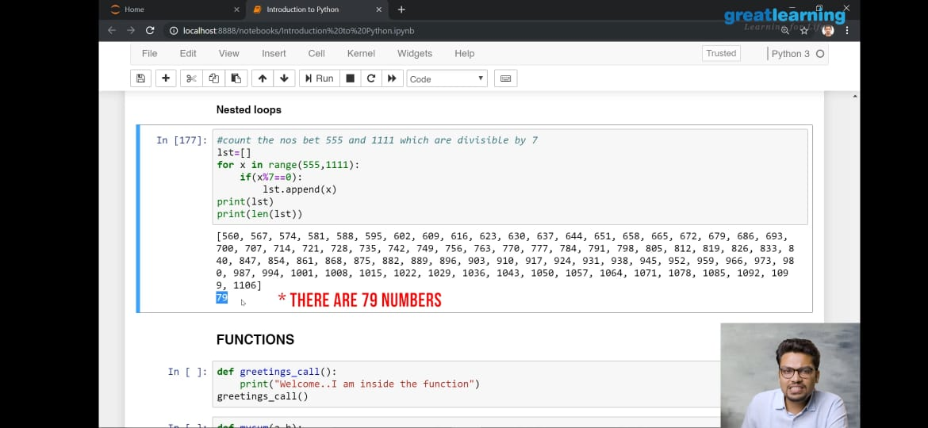

|  |
| --- |
|  |
|  |
|  |
|  |
|  |
|  |
|  |
|  |
|  |
|  |
|  |
|  |
|  |
|  |
|  |
|  |
|  |
|  |
|  |
|  |
|  |
|  |
|  |
|  |
|  |
|  |
|  |
|  |
|  |
|  |
|  |
|  |
|  |
|  |
|  |
|  |
|  |
|  |
|  |
|  |
|  |
|  |
|  |
|  |
|  |
|  |
|  |
|  |
|  |
|  |
|  |
|  |
|  |
|  |

**Program:**

|  |  |
| --- | --- |

include <stdio.h>

int main() {

double a, b, product;

printf("Enter two numbers: ");

scanf("%lf %lf", &a, &b);

// Calculating product

product = a * b;

// Result up to 2 decimal point is displayed using %.2lf

printf("Product = %.2lf", product);

return 0;

}